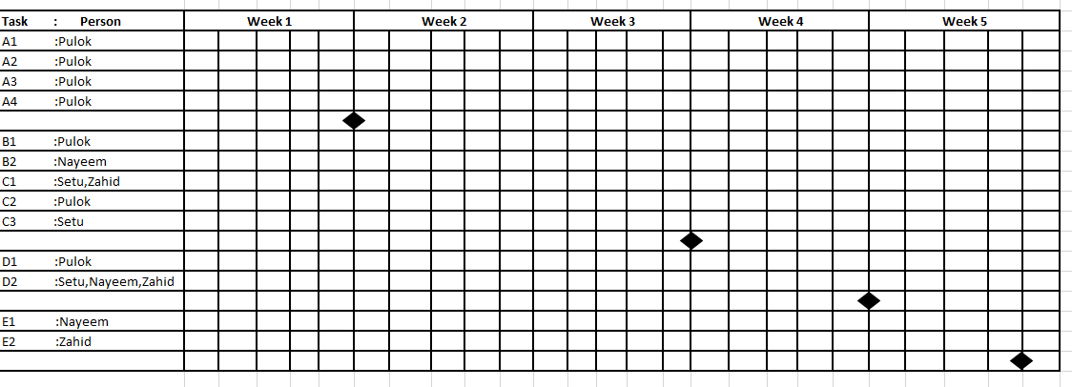

**Activity Key:**

**A. Planning and Requirement Analysis:**

1.Identify needs and benefits.

2.Meets with customers.

3.Identifying needs and project constrain.

4.Establish Product statement.

**Milestone**: Product Statement defined.

**B. Designing Phrase 1:**

1.Creating Mock Design.

2.Designing use case diagram.

**Milestone:** Initial designed completed.

**C. Designing Phrase 2:**

1.Designing Activity diagram.

2. Designing class diagram.

3. Designing ER diagram.

**Milestone:** Primary design completed.

**D. Management Phrase:**

1.Assigning task in jira.

2.Completing assigned tasked.

**Milestone:** Project management initiated.

**E. Storage Phrase:**

1.Implementing git technologies.

2.Storing project using git.

**Milestone:** Project backup stored.